Day 5 – Linux Assignment(VI Assignment)

**Ans 1:** To invoke vi editor with filename

**Ans 2:** Type few lines in a file

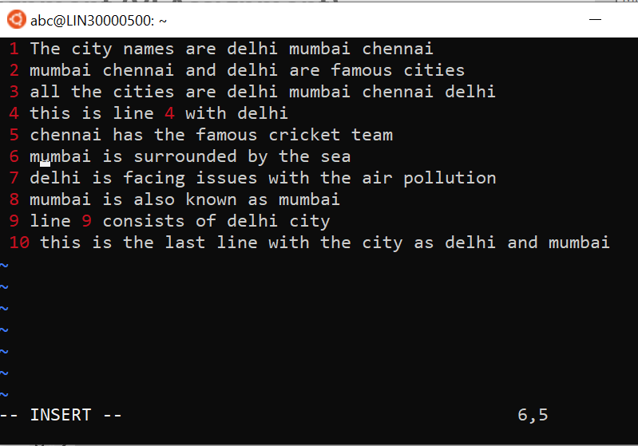

**Ans 3:** Save a file without exiting editor 🡪 esc key and then :w

**Ans 4:** Command for beginning 🡪 esc then :1 🡪 ending of line esc then :$

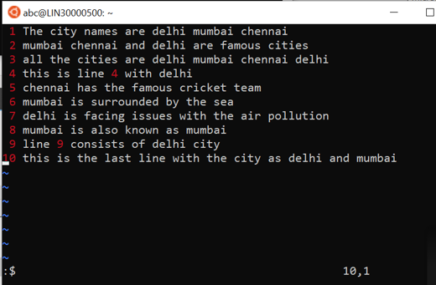

**Ans 5:** Delete top 2 line and paste it to bottom 🡪 2dd to cut then p to paste down

**Ans 6:** Copy last 2 line to top 🡪 2yy to copy then 🡪r for replace 🡪 p to paste down

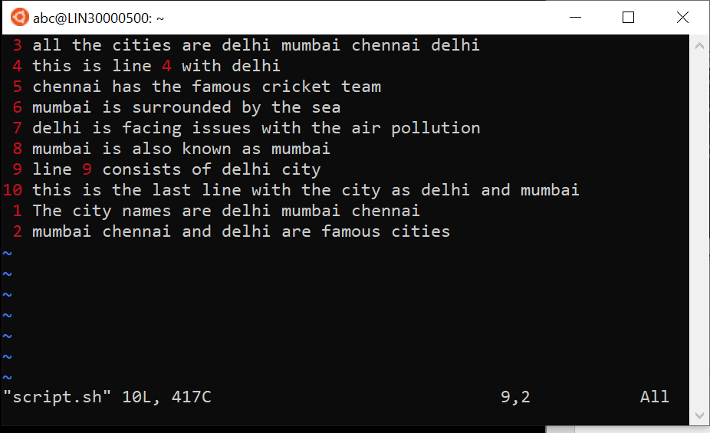

**Ans 7:** Combine last two line in a single line 🡪 Take a cursor on line then 🡪 J

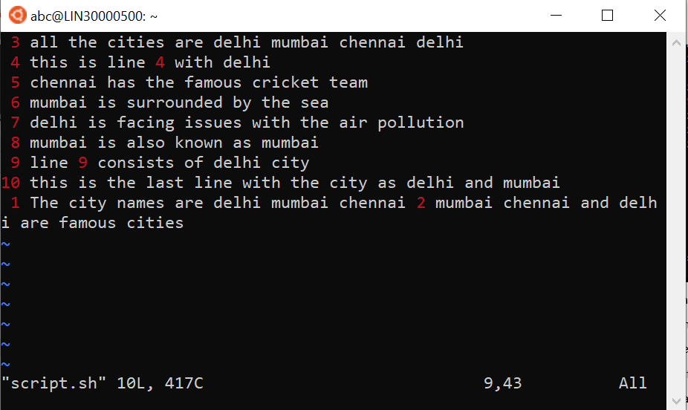

**Ans 8:** To insert above first line 🡪 go to replace mode and add the line

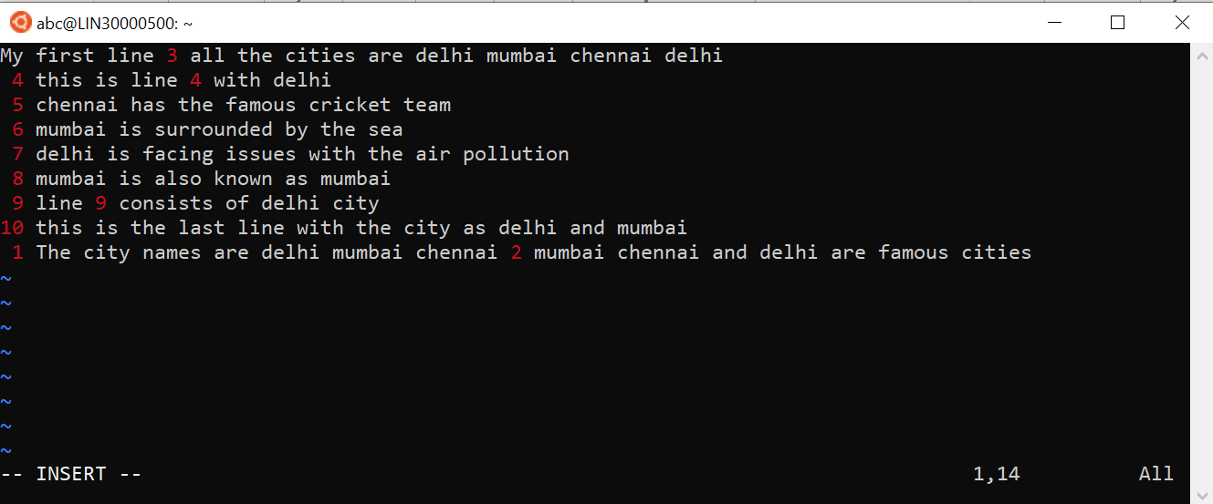

**Ans 9:** Take cursor where to copy 🡪 press p

**Ans 10:** To find delhi 🡪 /delhi

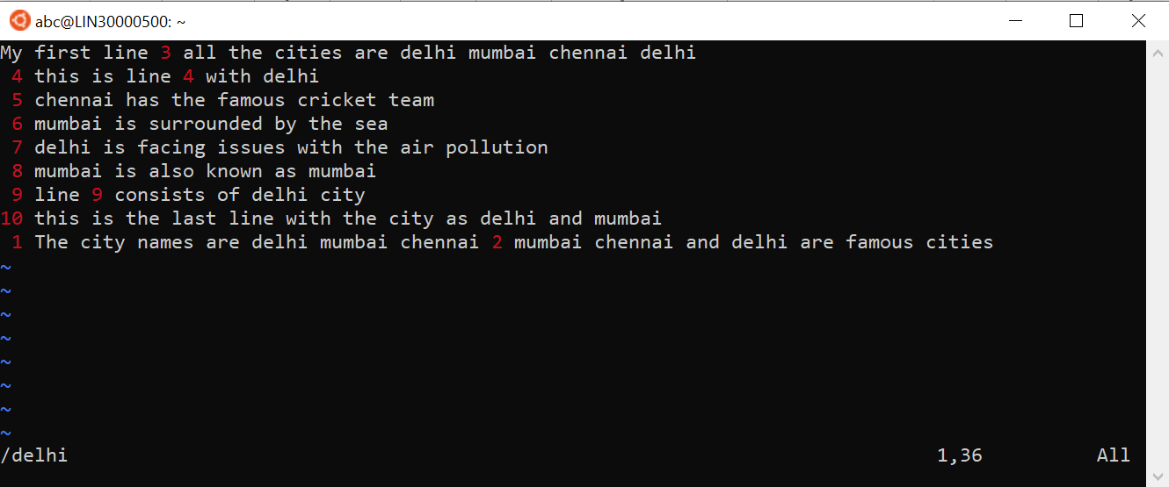

**Ans 11:** change single occurrence of delhi to Mumbai 🡪 :s/delhi/Mumbai

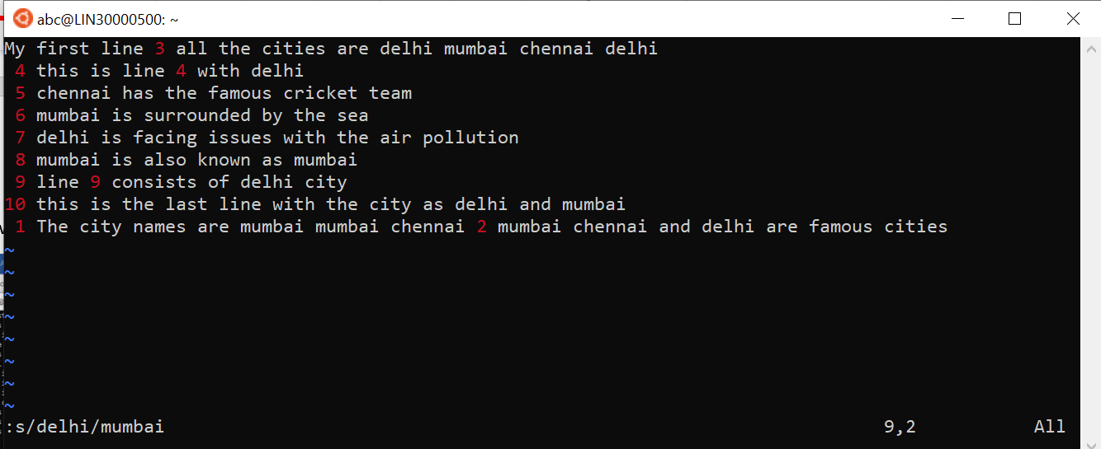

**Ans 12:** change all occurrence of delhi to Mumbai on a line 🡪 :s/delhi/Mumbai/g

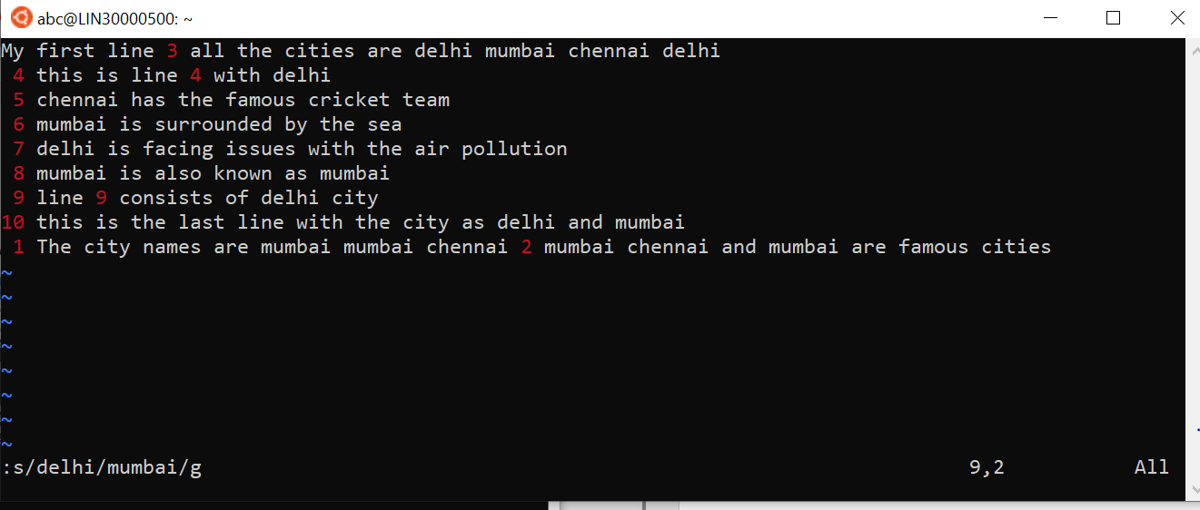

**Ans 13:** change all occurrence of delhi to Mumbai in entire doc 🡪 :%s/delhi/Mumbai

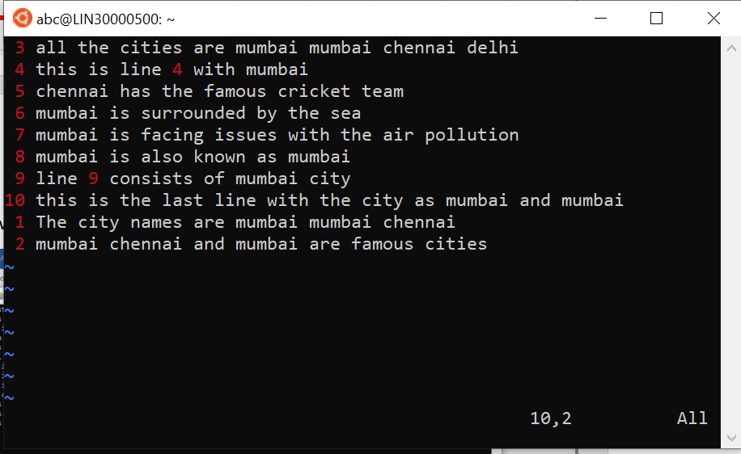

**Ans 14:** change all occurrence of delhi to Mumbai from line 3 to 11 🡪 :3,11s/delhi/Mumbai

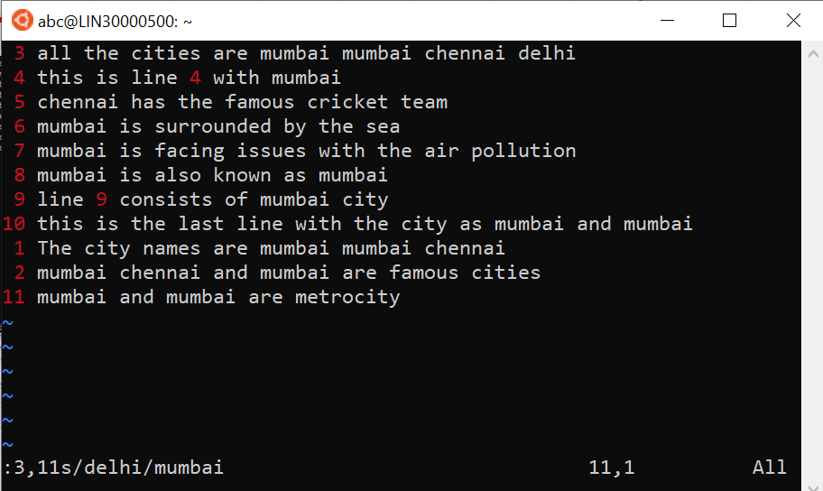

**Ans 15:** To undo the last work 🡪 u

**Ans 16:** To change occurrence of first delhi from selected lines 🡪 :3,11s/delhi/Mumba

**Ans 17:** To undo the last work and redo again and undo again 🡪 u then 🡪 ctrl + r then 🡪 u

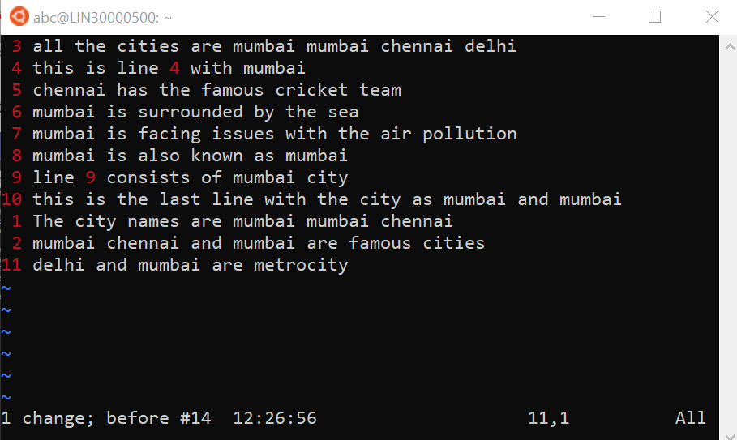

**Ans 18:** To change all occurrence of mumbai to delhi interactively 🡪 :%s/mumbai/delhi/gc

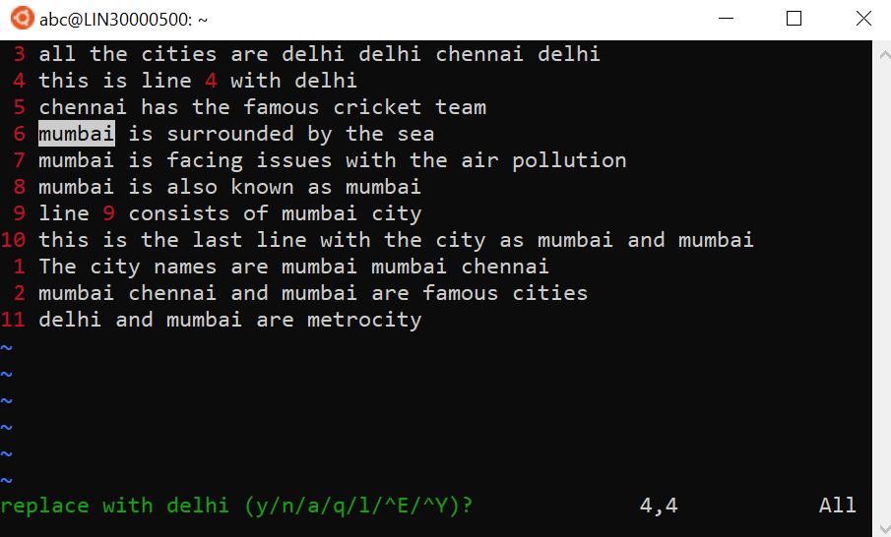

**Ans 19:** To search for a word backward 🡪 ?Mumbai

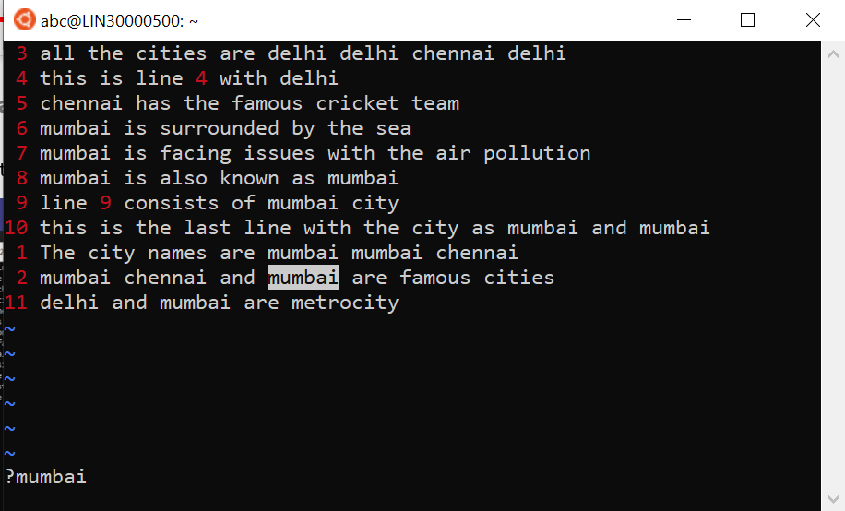

**Ans 20:** To search for a word forward 🡪 /Mumbai

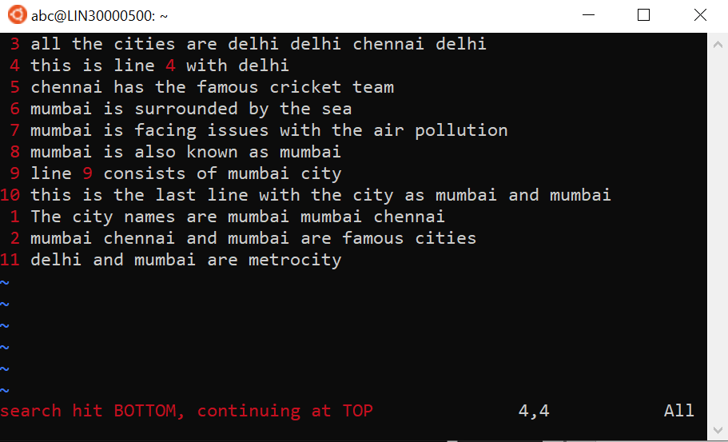

**Ans 21:** To join two lines 🡪 J

**Ans 22:** To enable line numbering 🡪 :set nu disable🡪 :set nonu

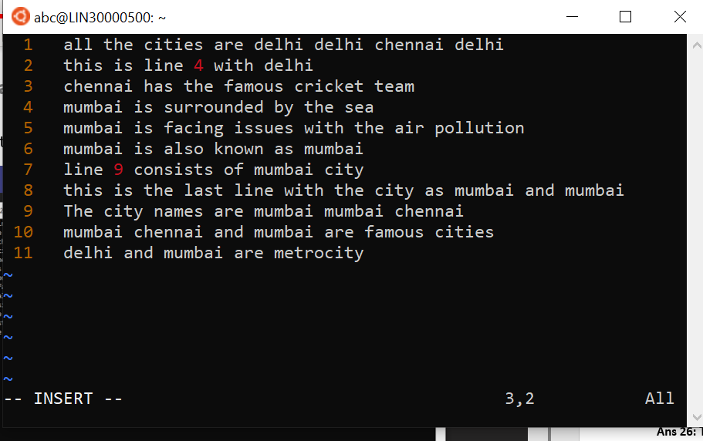

**Ans 23:** To make search case insensitive 🡪 set ic

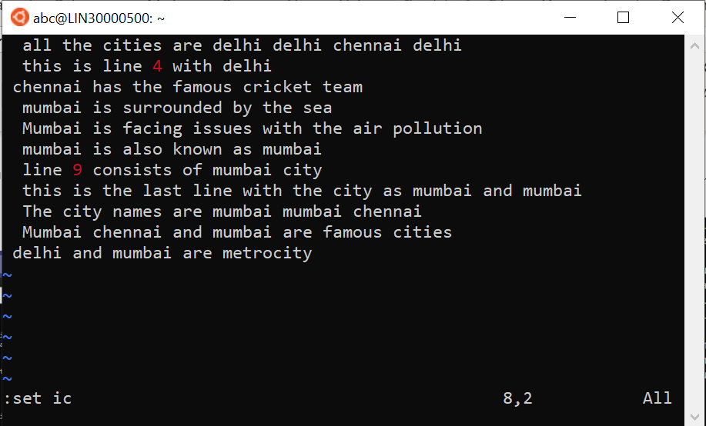

**Ans 24:** To select 4 lines and paste somewhere else 🡪 4dd 🡪Now p for paste

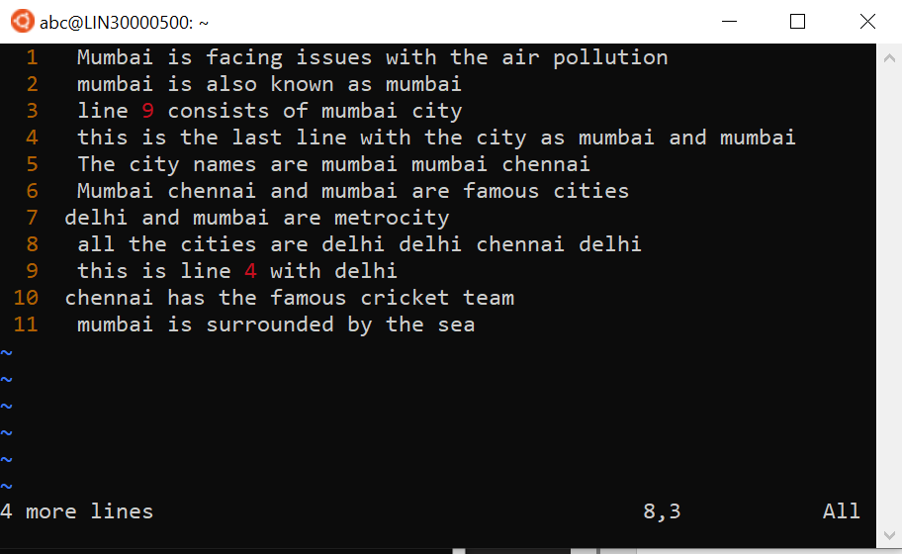

**Ans 25:** To delete the part of a line from cursor 🡪 d$

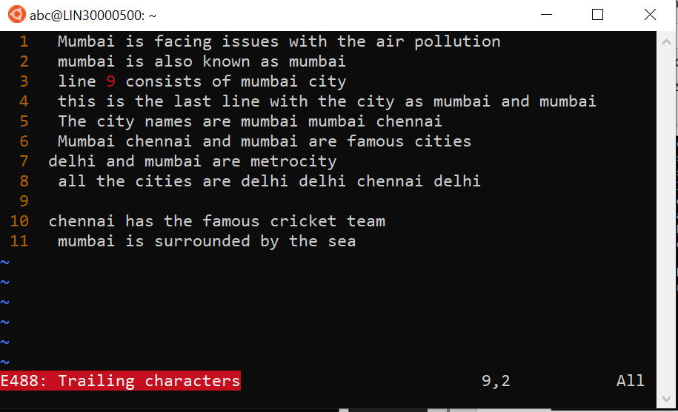

**Ans 26:** To delete the current word 🡪 esc 🡪 Move cursor to that word and 🡪 dw

